**Web Base**

**Ordering & Manufacturing**

**Management System**

Project Proposal

By

**Miss. Nontra Mahachanont 542115026**

**Mr. Parinya Panyanak 542115034**

Department of Software Engineering

College of Arts, Media and Technology

Chiang Mai University

Project Advisor

________________________

**Mr.Phudinan Singkhamfu**

|  |  |  |  |  |  |  |  |
| --- | --- | --- | --- | --- | --- | --- | --- |
| **Document Name** | **Version** | **Status** | | **Date** | **Viewable** | **Reviewer** | **Responsible** |
| **Documents** | | | | | | | |
| Web_Base_Ordering_&_Manufacturing_Management_System_Proposal_V.0.1.docx | V.0.1  - Add Abstract  - Add Chapter1  - Introduction & Background  - Adjust Project Name | | Draft | 07-02-2014 | NM, PP, PS | NM, PP | NM, PP |
| Web_Base_Ordering_&_Manufacturing_Management_System_Proposal_V.0.2.docx | V.0.4  - Add Chapter2  - Business Review  - Business Tools  - Software review  - Technology Review | | Draft | 14-02-2014 | NM, PP, PS | NM, PP | NM, PP |
| Web_Base_Ordering_&_Manufacturing_Management_System_Proposal_V.0.5.docx | V.0.5  - Add Development Tool Review  - Adjust Abstract  - Add Chapter3  - Quality Standards | | Draft | 17-02-2014 | NM, PP, PS | NM, PP | NM, PP |
| Web_Base_Ordering_&_Manufacturing_Management_System_Proposal_V.0.7.docx | V.0.7  - Add Chapter4  - Project Plan  - Adjust Technology Review  - Adjust Schedule & Milestone  - Adjust Project Name | | Draft | 18-02-2014 | NM, PP, PS | NM, PP | NM, PP |
| Web_Base_Ordering_&_Manufacturing_Management_System_Proposal_V.0.8.docx | V.0.8  - Add Chapter5  - References  - Adjust Chapter 1  - Adjust Chapter 2  - Adjust Chapter 4  - Adjust Project Name  - Fix inappropriate word | | Draft | 03-03-2014 | NM, PP, PS | NM, PP | NM, PP |
| Web_Base_Ordering_&_Manufacturing_Management_System_Proposal_V.0.9.docx | V.0.9  - Adjust Feature  - Adjust Project Name  - Adjust System architecture  - Fix inappropriate word | | Draft | 15-03-2014 | NM, PP, PS | NM, PP | NM, PP |
| Web_Base_Ordering_&_Manufacturing_Management_System_Proposal_V.1.0.docx | V.1.0  - Adjust Feature  - Adjust Project Name  - Adjust System architecture  - Fix inappropriate word | | Draft | 21-03-2014 | NM, PP, PS | NM, PP | NM, PP |

**Document History**

**\*NM = Nontra Mahachanont**

**\*PP = Parinya Panyanak**

**\* PS = Phudinan Singkhamfu**

**Table of contents**

**Chapter One | Introduction and Background** 6

**Chapter Two |Literature Review** 7

2.1 Business Review 7

2.2 Business Tools and Software Review 8

2.2.1Absolute |Solutions| Website 8

2.2.2Bakery land website 9

2.2.3PRIMS Software 10

2.3 Technology Review 11

2.3.1Spring Framework 11

2.3.2Cascading Style Sheets (CSS) 12

2.3.3HTML5 13

2.3.4Hack 14

2.4 Development Tool Review 15

2.4.1NetBeans 15

2.4.2MySQL Workbench 16

2.4.3Adobe Dreamweaver 17

**Chapter Three |Quality Standard** 18

**Chapter Four | Project Plan** 19

4.1 Motivation 19

4.2 Aims 19

4.3 Objectives 19

4.4 System Architecture 20

4.5 Deliverables and Limits 21

4.5.1 Deliverables 21

4.5.2 Limits 23

4.7 Schedule & Milestones 24

**Chapter Five | Reference…………………………………………………………………………….**28

# **Chapter One | Introduction and Background**

# Formerly, there are many problems about manufacturer that manage their order. These things can occur in Phungnoi bakery manufacturer and affect to another part while they are not obtaining their correctly ordering information. When these situations happen, most of them may try to re-check ordering to resolve their wrong ordering information. The general ways that Phungnoi bakery may use in this situation were finding a new product to replace the lack ordering or increase the number of workers to re-check the entire of ordering, so it wasted more time to resolving the problems. By these ways, if they aware enough, they may increase the effectiveness of the worker. Because the accuracy in ordering is critical since they know that main ordering is correct, may be some ordering is lost, but not know where the defect is and how they can re-check it become to the right data.

# Nowadays, there are many technologies and tools developed for many purposes. So the manufacturer is cannot handle their ordering information and control their production may use these technologies to solve it. The technology that very useful and accuracy obtain an ordering from wholesalers and also calculate all ingredients of production. With this, they can use the information in the system and share it to another worker with the same document. When their workers see this information, they may understand it instantly and can cooperation work with another colleague. This solution may be a good way to managing to order system, but there is one important problem that happens in production. The problem is they cannot control their materials anymore after getting ordering information. Since manufacturer cannot know that how many materials are uses in production day. So the calculation ingredients will affect to the production part.

# With these problems, our group decides to create Web Base Ordering & Manufacturing Management System to solve all previous problems. By creating as a web application with consists with order management system, ingredient management system and summary report system. The main objective of this system is to handle the ordering information and control the production part for estimate the ingredients of the manufacturer. We hopefully that this system and all function implemented will solve the manufacturer management problem.

# **Chapter Two |Literature Review**

## Business Review

**Overview**

Web Base Ordering & Manufacturing Management System is a web application that derived by JSP, HTML5, and CSS3. It is a web that created for helping the manufacturers estimate about how much to produce a product or how much ingredient needs to used in production part. Then, it can help the wholesaler to order and manage their ordering information easily.

**Target**

The main target of Web Base Ordering & Manufacturing Management System is to collect the orders from the wholesalers for manage production and also analyze how many ingredients needs to use in production from ordering information and report it.

**Benefit**

* The wholesaler gets convenient to order the bakery.
* The wholesaler can manage their order instantly.
* The wholesaler can know their ordered history.
* The manufacturer can know how many bakeries should be production.
* The manufacturer can know ordered history.
* The manufacturer can know their production history.
* The manufacturer can control the usage of ingredients.
* The manufacturer can control the standard of bakery.
* The manufacturer can produce accuracy bakery for each wholesale ordering.

## Business Tools and Software Review

## Absolute |Solutions| Website

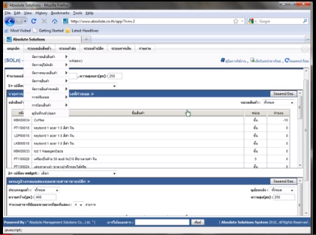

**Figure 1 Absolute |Solutions| website Review** [7]

## Software Description

Figure 1: This website is the business management website that using technology cloud computing that provides server, database, and IT expert. The aims are to improve company to better management. By use the wholesale and retail system, store system and order system. [7]

## Pros

* All data is security from virus on machine.
* The user can save investment.
* Support using this web site with every operation system.
* Support alert message with SMS and email.

## Cons

* Support only internet access areas.
* No estimate the ingredients from ordering information.
* No summary report system.

## Bakery land website

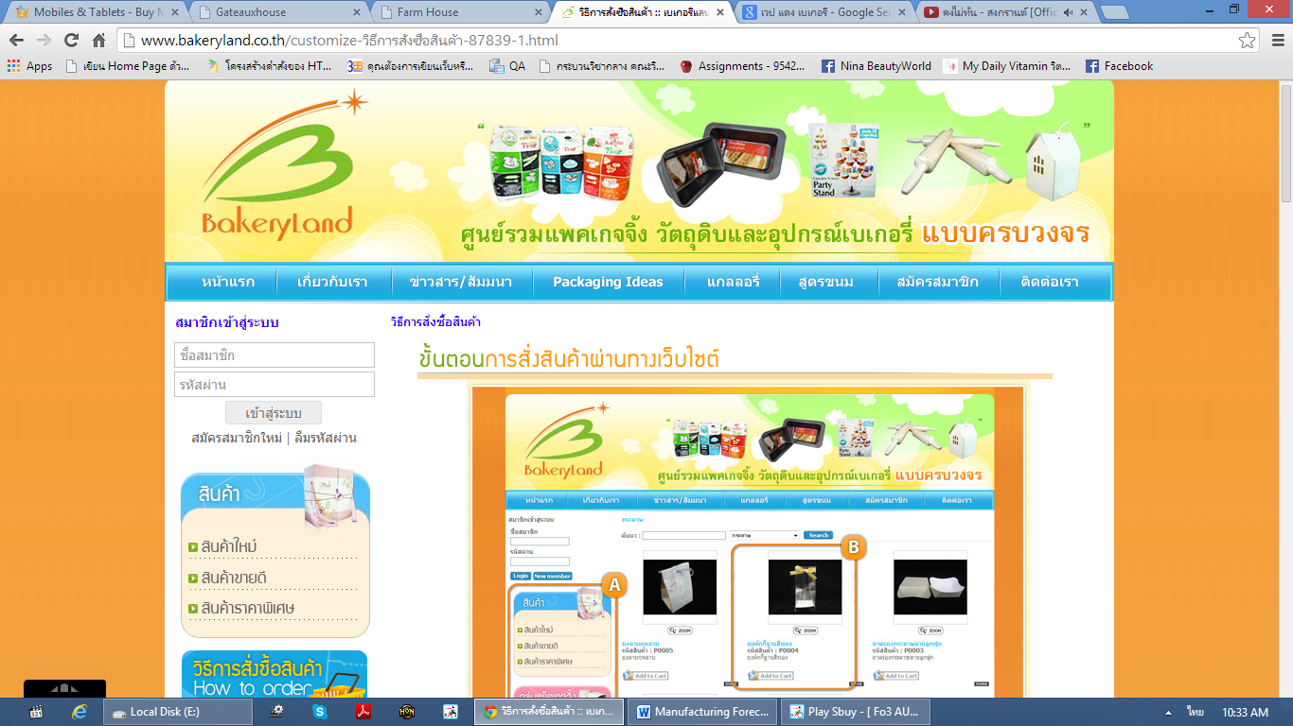

**Figure 2 Bakery land website Review** [8]

## Software Description

Figure 2: This website is the bakery online website that using for trading their bakery. It has many type of product included package and bakery material. The aims are to improve company to better marketing. By use the internet to sale the product. [8]

## Pros

* The user can order the product through the website.
* Have tutorial description for ordering.
* Good category management.

## Cons

* Support only internet access areas.
* No estimate the ingredients from ordering information.
* No summary report system.

## PRIMS Software

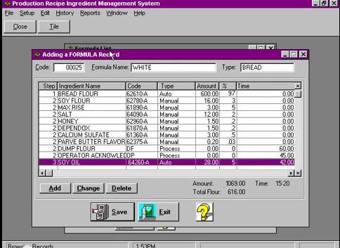

**Figure 3 PRIMS software Review** [9]

## Software Description

Figure 3: This program is the ingredient management program in the enterprise. It’s has many feature to support such as scheduling, insures recipe compliance, eliminates operator errors, eliminates waste and records actual inventory usage. [9]

## Pros

* Easy to use for no user experience to operation.
* Flexible technology to control over manual operation.
* Record each step in the process.
* Fast and accuracy.

## Cons

* No membership and login support.
* No online interactive.
* No coverage report type function.

## Technology Review

## Spring Framework



**Figure 4 Spring Framework Logo** [12]

## Technology Detail

Figure 4: The spring framework is an open source tool for supporting Java-based enterprise application development. This framework use to develop any java application and make J2EE easy to use. It contains pattern and configuration for programming which can be deployed on any platform. It also supports various components to work together such as JDBC and Hibernate. [11]

## Alternative Technology

* ASP.NET Framework

## The selection of this technology

* Support MVC pattern.
* Support .Net and java.
* Easy for unit testing when split it to another part with JUnit.
* Support to connect with various components and technologies.

## Cascading Style Sheets (CSS)



**Figure 5 CSS Logo** [14]

## Technology Detail

Figure 5: CSS is stands for Cascading Style Sheets. It is a last version of CSS style sheets used to design element of website such as layout, color, size or font of website. Then display HTML elements that presentation of web pages. [13]

## The selection of this technology

- CSS make web pages look better than only HTML does.

- Helps to design the web flexibility.

- Redesign (i.e. colors, size, fonts) with not has effect to HTML code.

- The feature more than the old version such as Combinatory, CSS Selectors, Pseudo-elements, Style properties.

## HTML5



**Figure 6 HTML5 Logo** [6]

## Technology Detail

Figure 6: HTML5 is the lasts revision of the HTML. It is a markup language to create a user interface for present contents that can be displayed in a web browser. [6]

## Alternative Technology

* Another HTML version
* XHTML

## The selection of this technology

- Makes creating accessible sites easier.

**-** Allow other can access easily.

**-** Simple and clean.

**-** Easy to handle error.

**-** Reduce the external plug-in such as flash.

**-** Support for local storage.

**-** New content-specific elements, like <article>, <footer> and <header>.

**-** New form controls, like calendar, date, time, email and URL.

## Development Tool Review

## NetBeans



**Figure 8 NetBeans Logo** [9]

## Development Tool Description

Figure 8: NetBeans is an open-source program to integrated development environment for developing with any language such as Java, PHP, C++ and other programming language. It is referred to developing Java desktop applications and also develops web application. It's constantly improving Java Editor, provide many features and an extensive range of tools, templates and samples. [10]

## Alternative Tool

* Eclipse
* IntelliJ IDEA

## The selection of this tool

* Open source for any users no need license or contract.
* Provide many features necessary for MVC pattern development.
  + Support Ant and Maven – no custom built system that only works in the IDE.
  + Includes new features for editing/debugging HTML5.
  + Written using swing.
  + Built-in support for version control systems plug-ins. For example, it can be a nightmare to get SVN configured correctly on 64 bit systems.

## MySQL Workbench



**Figure 9 MySQL Workbench Logo** [16]

## Development Tool Description

Figure 9: MySQL Workbench is an open source relational database management system which used for develop database architects. It can do such as provides data modeling, comprehensive administration tools for server configuration, SQL development, user administration and backup. Then also supports many development tool for create a web application such as Eclipse and NetBeans. [15]

## Alternative Tool

* Microsoft Access
* SQLite
* TomCat
* Appserve

## The selection of this tool

* Easy to integrate with many development tools.
* Provide many features support.
* More security.
* Flexible for using and manage via other tools.
* Can visualize table relationships.

## Adobe Dreamweaver



**Figure 10 Adobe Dreamweaver Logo** [1]

## Development Tool Description

Figure 10: Adobe Dreamweaver is the tool for design and develop the website that provides a visual interface for making and editing HTML websites. [1]

## Alternative Tool

* Notepad++
* CoffeeCup Free HTML Editor
* PageBreeze
* TextMate

## The selection of this tool

## Complete function that necessary to create a website.

* Work with offline.
* Support with layout tool.
* Can split the code and design of the webpage at the same time.

**Chapter Three| Quality Standard**

## 3.1 ISO29110 for Very Small Entity (VSE)

ISO29110 is a guide applies to a Very Small Entity (VSE), enterprise, organisation, department or project up to 25 people, dedicated to software development. The Guide provides Project Management and Software Implementation processes which integrate practices based on the selection of ISO/IEC 12207- *Systems and Software Engineering —Software Life Cycle Processes* and ISO/IEC 15289*Software Engineering – Software Life Cycle Process – guidelines for the content of software life cycle process information products (documentation)* standards elements. [2]

### Project Management Process

The purpose of the Project Management Process is to improve the success rate of projects in all areas of knowledge, which allows complying with the project’s objectives in the expected quality, time and cost. [3]

**Activities**

* Project Planning Process
* Project Plan Execution Process
* Project Assessment and Control Process
* Project Closer Process

### Software Implementation Process

The purpose of the Software Implementation process is the systematic performance of the analysis, design, construction, integration and tests activities for new or modified software products according to the specified requirements. [4]

**Activities**

* Software Implementation Initiation Process
* Software Requirements Analysis Process
* Software Architectural Design Process
* Software Construction Process
* Software Integration and Test Process
* Software Delivery Process

# **Chapter Four | Project Plan**

## Motivation

Nowadays, Phungnoi bakery manufacturer has complicated their ordering information. Sometimes can manage their information, and some are cannot. Then there are affect to the production part that produces accuracy ordering information. By the way, as the technology is growing every day, some company turn it as an advantage by use the system to help them solve the problem by managing data in their business.

So we realized that using standard order management system to solve the problem for ordering and managing in the system is easy and faster way to solve the problem, but the disadvantages about this way are ordering online, not support for production part. The entire of ordering information cannot be analyzing their summary to apply with the production department of the manufacturer and cannot be an estimate the ingredients to limit their materials. We are unable to handle it anymore even if the manufacturer are collect the complete ordering information from the program to analyze and determine to resolve their over ingredients in the production by themselves. The estimating still continues because the manufacturer not knows about real ingredient usage of the production compare with ordering information, they just continue to estimating it in every day but almost unstable and not standard.

With these reasons, we think there must be some order to handle the problems that can help the manufacturer who needs to obtain online ordering from wholesalers and know their actual number in production every day. This system should still able to use the report for limiting their cost that can be controlled and has many function to help solve these problems easily, thereby resulting in “Web Base Ordering & Manufacturing Management System."

## Aims

The aim of this project is to develop a website that provides web base for wholesale, order management, ingredient management, and report to the manufacturer, also to be an ordering system that makes an order with the manufacturer as quick and easy as possible. Then also increasing the effectiveness of the manufacturer will control their standard and the strictness of the manufacturing will limit their budget.

## Objectives

* Alternative way to help manufacturer estimate ingredients and control usage.
* Provide multiple systems to support the manufacturer can cooperation.
* Activities of the manufacturer are a summary into the report for easy to controlled.
* Alternative way to support wholesaler ordering conveniently.

## System Architecture

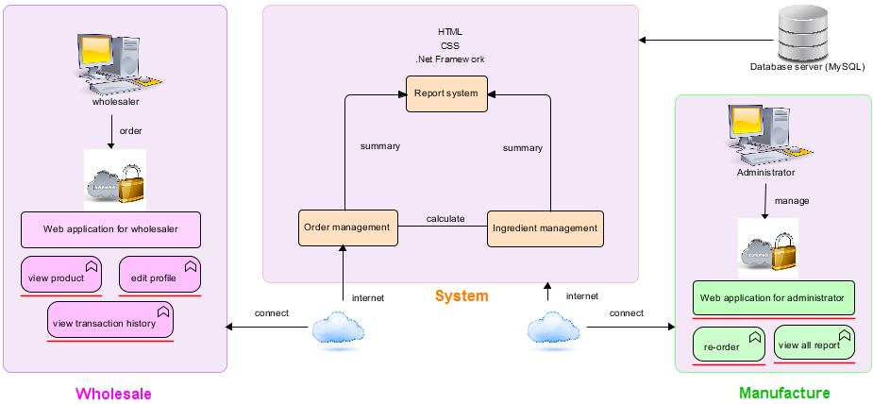

Figure 4.4.1: Web Base Ordering & Manufacturing Management System

Figure 4.4.1: Shows the overview of the Web Base Ordering & Manufacturing Management System. The system uses internet to connect with web application. The system provides order management system to calculate ingredient management system and summary to report system. Every process, summary information of the report may help the manufacturer can know the amount of ordering and ingredients usage in each day. It will store all management information to the database system (MySQL) and display summary information to the manufacturing side. Web Base Ordering System & Manufacturing Management System consisted of two sides. The first side supported automatically to wholesaler ordering online and also can manage their order. Another side has administrator to control system and manage wholesale ordering information. The administrator and the wholesaler can view their history of their own information.

## Deliverables and Limits

### Deliverables

**4.5.1.1 Progress Report I**

* **Feature#1:** Member Management System
  + - * Wholesaler and admin can login to the system.
      * Wholesaler and admin can log out from the system.
      * Wholesaler and admin can edit their profile.
      * Wholesaler and admin can view their profile.
      * Admin can create accounts of users.
      * Admin can delete accounts of users.
      * Admin can edit accounts of users.
      * Admin can search user’s account by user ID and name.
      * Admin can specify user’s type.
* **Feature#2:** Order Management System
  + - * Wholesaler and admin can search bakery details by bakery’s name, type and price.
      * Wholesaler can make an order of bakery.
      * Wholesaler can repeat the ordered of bakery from their history.
      * Wholesaler can save unfinished order of bakery.
      * Wholesaler can edit their submitted order.
      * Wholesaler can receive notification successful ordering by SMS and email.
      * Admin can manage bakery’s details.
      * System can sort production date from order information.
      * System can calculate the total price.
      * System can calculate the discount of ordered.
      * System can calculate the ordered bakery in each type.
      * System can notification when receive ordering information.

**4.5.1.2 Progress Report II**

* **Feature#3:** Ingredient management System
* Admin can manage details of bakery by provide the bakery’s name, ingredient and bakery’s net.
* Admin can manage ingredient type information.
* System can calculate the actual number to be produce bakery.
* System can calculate ingredient will be used in the production.
* System can calculate ingredient will be used in each type.
* System can calculate expected net in each bakery’s type.

**4.5.1.3 Progress Report III**

* **Feature#4:** Summary Report System
* Wholesaler can view their order history by day, month and year.
* Admin can view wholesaler’s history by day, month and year.
* Admin can view summary wholesale order by day, month and year.
* Admin can search wholesaler’s history by name and ID.
* Admin can make wholesalers order’s report.
* Admin can make bakery preparation’s report.
* Admin can make real production’s report.
* Admin can make ingredient usage’s report.
* Admin can make bakery net assurance’s report.
* All report can convert to being a graph in PDF form.
* Wholesaler and admin can print their report.

* Manage = add, edit, delete

**4.5.1.4 Software Document**

* Project Proposal
* Project Plan
* Software Requirement Specification
* Software Design Document
* Use Case
* Use Case Description
* Class Diagram
* Sequence Diagram
* Activity Diagram
* Testing Document
* Test plan
* Unit Test Document
* System Test Document
* Test Report
* Unit Test Document
* Integration Test Document
* Traceability Record
* Software Quality Assurance
* Progress Status Report
* Self-Assessment Report

### Limits

- Membership is required for using all function in the application.

- Wholesaler cannot register them as a member.

- The application required Internet connection to execute.

- This application supports only Phungnoi bakery manufacturer as a sample for developing and testing the system.

- Estimate function shall calculate only ingredients and net.

**4.6 Future work**

* These systems can support another functions such as stock management system and billing management system.
* This system can be used in any manufacturer.
* This system can use other technologies to provide more convenient service.
* This system can support other major operating system platforms.

## Schedule & Milestones

According from Figure 4.7.1 to Figure 4.7.5 was show the schedule and milestones of Web Base Ordering & Manufacturing Management System. During period of time, there are work terminologies. And the description is shown below that:

**Schedule Plan:**

|  |  |  |
| --- | --- | --- |
| **Progress** | **Duration** | **Task** |
| **Proposal** | **Start:** 07 February 2014  **End:** 02 April 2014 | Proposal Document |
| **Progress I** | **Start:** 06 April 2014  **End:** 05 June 2014 | **Feature#1:** Member Management  **Feature#2:** Order Management |
| **Progress II** | **Start:** 20 June 2014  **End:** 01 August 2014 | **Feature#3:** Ingredient Management |
| **Progress III** | **Start:** 07 August 2014  **End:** 19 September 2014 | **Feature#4 :** Summary Report |
| **Final Progress** | **Start:** 27 September 2014  **End:** 20 November 2014 | System and Document are complete |

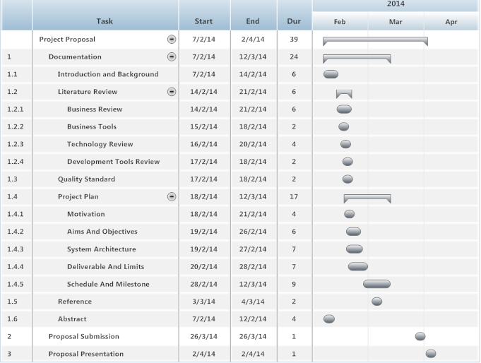

**Figure 4.7.1: Proposal Milestone MilestMilestone**

As shown in figure 4.7.1, There are the details of each task that our have done with the documentation which represent by form of start date, end date and duration.

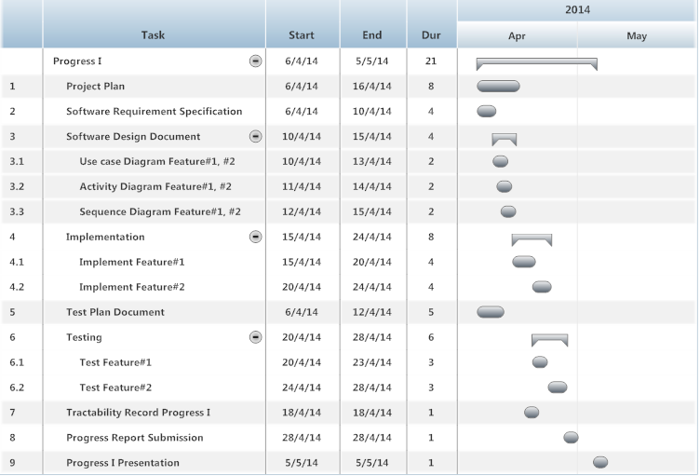

**Figure 4.7.2: Progress Report I Milestone**

As shown in figure 4.7.2, We will start develop the feature#1 and #2. In addition we will also start to do the development plan, quality plan, software requirement specification, software design, test plan and traceability record which represent by form of start date, end date and duration.

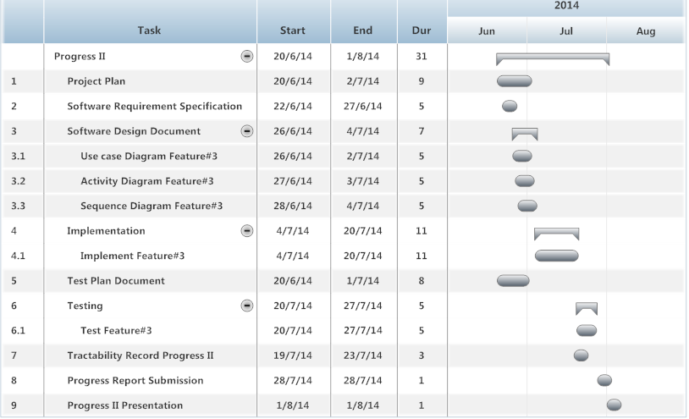

**Figure 4.7.3: Progress Report II Milestone**

As shown in figure 4.7.3, We will start develop the feature#3. In addition we will also start to do the development plan, quality plan, software requirement specification, software design, test plan and traceability record which represent by form of start date, end date and duration.

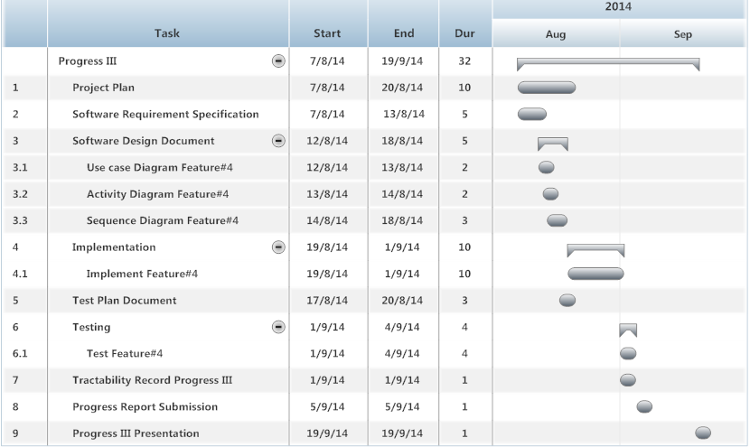

**Figure 4.7.4: Progress Report III Milestone**

As shown in figure 4.7.4, We will start develop the feature#4. In addition we will also start to do the development plan, quality plan, software requirement specification, software design, test plan and traceability record which represent by form of start date, end date and duration.

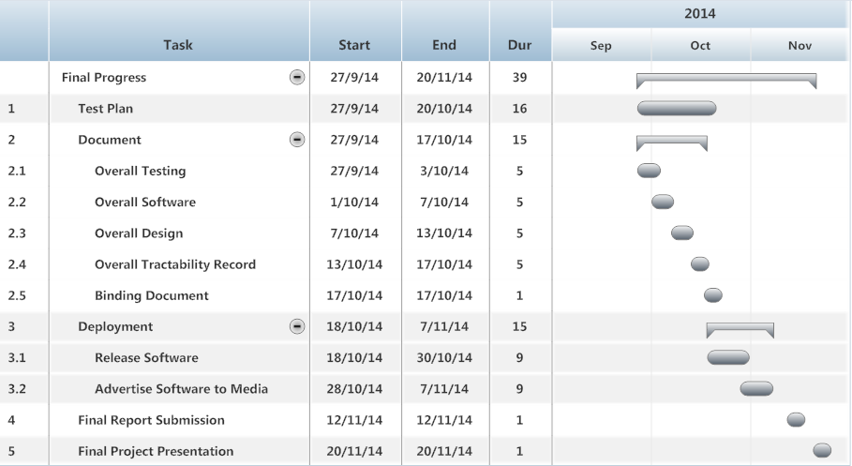

**Figure 4.7.5: Final Progress Report Milestone**

As shown in figure 4.7.5, We will start to do the development, test plan and deployment which represent by form of start date, end date and duration.

**Chapter Five | References**

[1] Wikipedia “Adobe Dreamweaver CS6” [Online]. Available from http://en.wikipedia.org/wiki/Adobe_Dreamweaver

[2] VSE [Online]. Available from http://profs.etsmtl.ca/claporte/English/VSE/Deploy-Pack/Entry

[3] Wikipedia “Project Management Process” [Online]. Available from http://en.wikipedia.org/wiki/Project_Management_Professional

[4] Software Implementation Process [Online]. Available from http://profs.etsmtl.ca/claporte/ English/VSE/Deploy-Pack/Entry%20Profile-DP-Software

[5] Wikipedia “HTML” [Online]. Available from <http://en.wikipedia.org/wiki/HTML>

[6] Absolute |Solutions| [Online]. Available from https://www.absolute.co.th/index.html

[7] Bakery land website [Online]. Available from http://www.bakeryland.co.th/

[8] PRIMS [Online]. Available from http://www.foodsafetyconnect.com/Food-Safety—Quality-Management-1069/PRIMS--Production-Recipe-Ingredient-Management-Software-328/ and http://matrixcontrols.net/pdf/PRIMS-ROI-Advantage-Summary.pdf

[9] Kapilbulsara “Netbeans” [Online]. Available from http://www.kapilbulsara.com/tag/netbeans/

[10] Software Picks Network “Netbeans” [Online]. Available from http://www.softpicks.com/software/Development/Miscellaneous/NetBeans-IDE-180921.htm

[11] Wikipedia “Spring Framework” [Online]. Available from http://en.wikipedia.org/wiki/Spring_Framework

[12] Sedona “Spring Framework” [Online]. Available from http://blog.sedona.fr/

[13] Wikipedia “Cascading Style Sheets” [Online]. Available from http://en.wikipedia.org/wiki/Cascading_Style_Sheets

[14] Microsoft “CSS3 Animations” [Online]. Available from http://blogs.microsoft.co.il/gilf/2011/12/14/css3-animations/

[15] Oracle “MySQL Workbench” [Online]. Available from http://www.oracle.com/technetwork/issue-archive /book-beat-archive-1878886.html

[16] MySQL Workbench [Online]. Available from http://osx.wdfiles.com/local--files/icon:mysqlworkbench/MySQLWorkbench.png